Grand Final - Information Sheet

**Return Plane Ticket Options**

Each option has 3 different types of tickets:

* *Red eDeal or Saver* – this is the cheapest economy ticket and includes a light meal for 1 hour flights or a small meal for over 2 hour flights. There is a small number of these tickets available, so you need to book early to get this price.
* *Flex or Flexi* - this is the standard economy ticket and includes a light meal for 1 hour flights or a small meal for over 2 hour flights. This ticket is transferable, this also allows you to change flight dates and times at a later date.
* *Business* – this class has a larger seat and more leg room. Every flight comes with free alcohol and high quality meal.

**Stop-over**

A stop-over is where you have to take 2 different flights to get to your destination. That is you have to fly to one city, wait there and then catch another flight to get to your final destination. For example, to get from Perth to Sydney, you could travel from Perth to Adelaide, then another flight from Adelaide to Sydney.

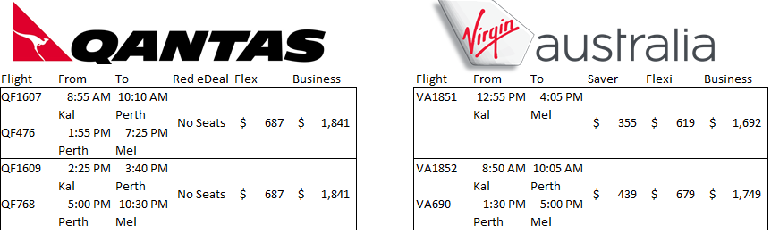

4 Flight options **FROM KALGOORLIE TO MELBOURNE on FRIDAY 27/09/2019**  (All times are in WA time)



1:30 PM 5:50 PM

5:00 PM 10:30 PM

1:55 PM 7:25 PM

2

1

3

4

4 Flight options **FROM MELBOURNE TO KALGOORLIE on SUNDAY 29/09/2019**  (All times are in WA time)

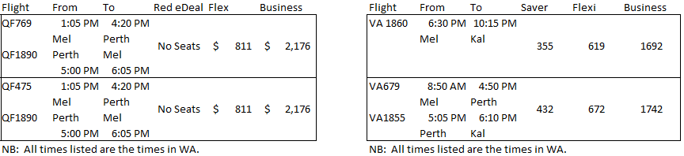

9:45 PM

12:10 PM

5:00 PM 6:05PM  
Perth Kal

7:25 AM 11:40 AM

12:05 PM 4:20 PM



5:00 PM 6:05PM  
Perth Kal

2

1

3

4

**NOTE:** All of the above times are Western Australia Times.

# Taxi Services – Melbourne

In order to catch at taxi from the Melbourne airport, you are required to walk to the nearest taxi rank, which is located at the Melbourne airport, where you proceed to the next taxi available.

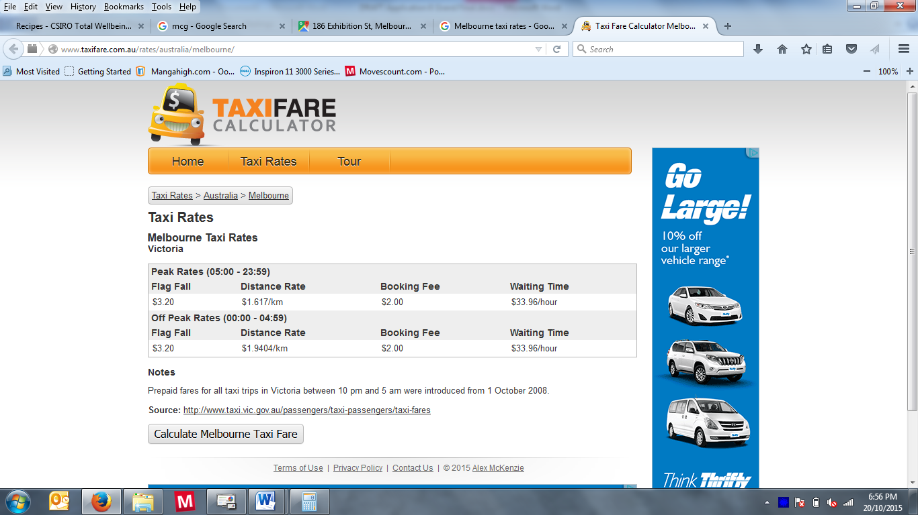

**Flag Fall** – Flag fall is the initial fee. This is an upfront fee that must be paid, no matter how many kilometres you travel.

**Distance Rate** – this is the rate you pay for every kilometre or part kilometre travelled. Part kilometre means the distance is rounded up to the next whole kilometre.

**Booking Fee** – this is an extra payment that is made if you phoned ahead to arrange a taxi to meet you at a particular time and place. No booking fee is required when catching a taxi at an airport.

**Waiting Time** – this fee is charged when you make a taxi wait for you. If you booked a taxi for a set time and you are more than 10 minutes late, they will charge you this rate for every hour or part hour they had to wait. This fee is also charged if you have asked the taxi to wait while you hop out of the taxi to go do something.

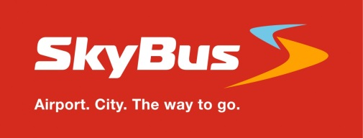

The SkyBus service takes you express between Melbourne Airport (Tullamarine) and Southern Cross Station in the heart of Melbourne city – 24/7. The complimentary SkyBus Hotel Transfer Service operates from our Southern Cross Station terminal.

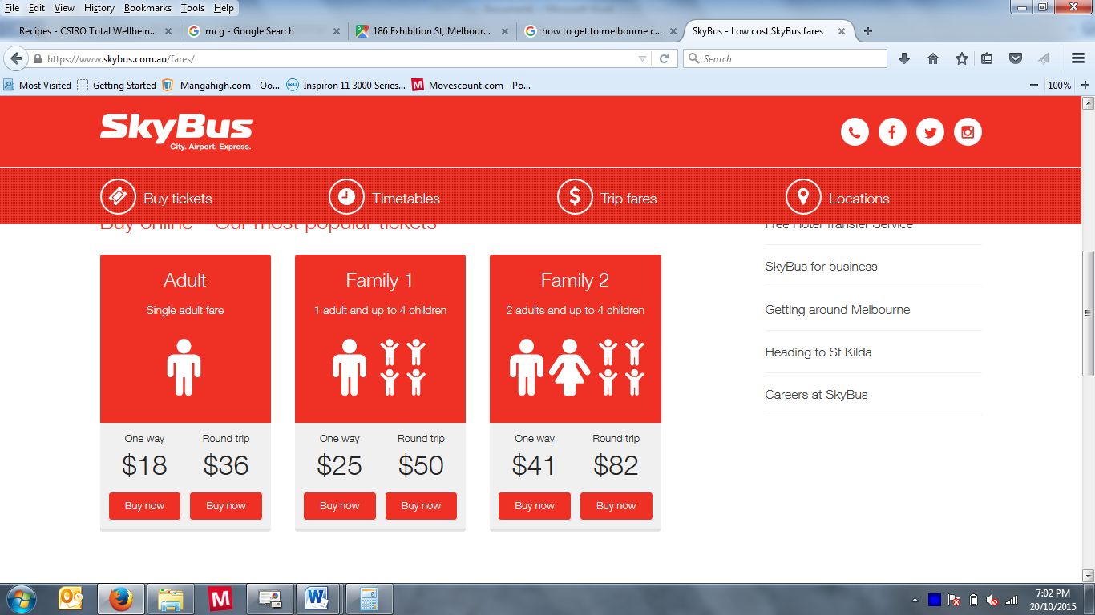As a SkyBus passenger, we can transfer you to select accommodation from our city terminal using our fleet of mini buses.

For your convenience, the SkyBus Hotel Transfer Service operates:

* Monday to Friday 06:00 – 22:30 (Melbourne Time)
* Saturday & Sunday 07:30 – 17:30 (Melbourne Time)

